**REQUIREMENTS NOT MET**

N/A

**PROBLEMS ENCOUNTERED**

I originally could not get Atmel Studio to recognize our board when trying to emulate the code. I uninstalled then reinstalled multiple times, but it didn’t work. I tried updating my USB drivers and it still didn’t work. I was reluctant to try the instantiation file by the PI because the website seemed a little sketchy and I wanted to use it as a last resort. It ended up working and Atmel Studio now recognizes the board.

**HOMEWORK EXERCISES**

N/A

**PSEUDOCODE/FLOWCHARTS**

**N/A**

**PROGRAM CODE**

N/A

**APPENDIX**

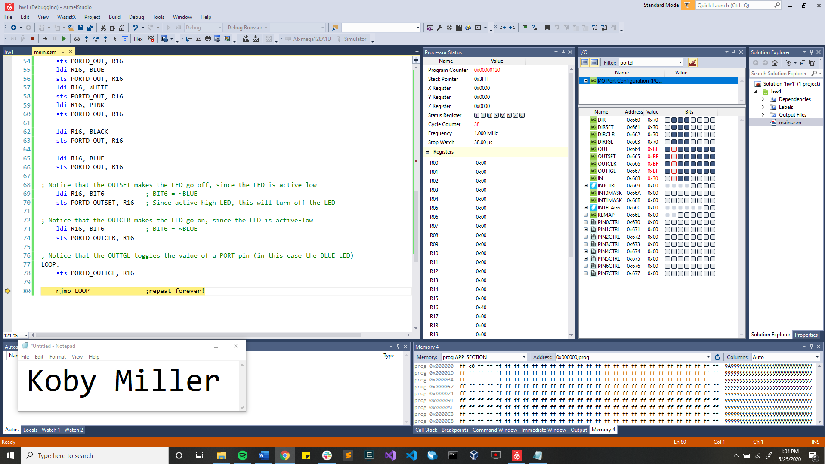Screenshot from the results of step 12 (the simulation):

Screenshot from the results of step 14 (the emulation):

